[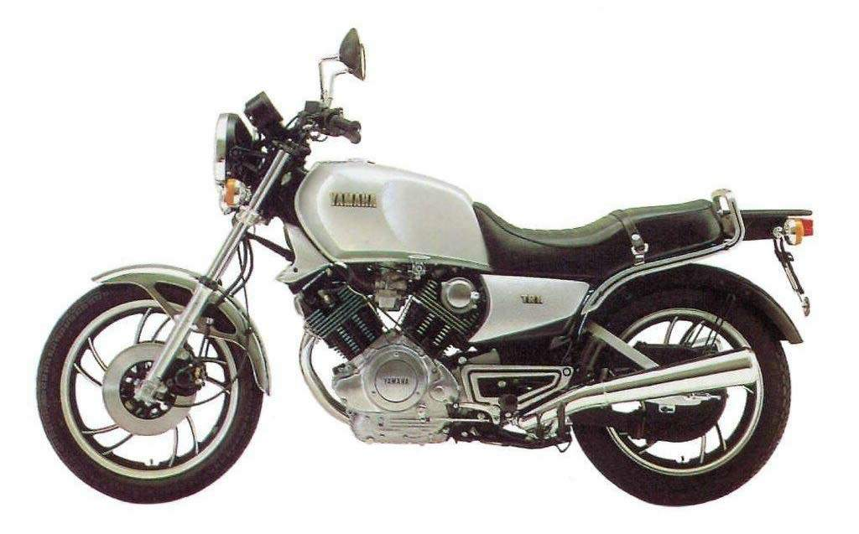](http://www.google.ch/url?sa=i&rct=j&q=&esrc=s&source=images&cd=&cad=rja&uact=8&ved=0ahUKEwibhb343oTRAhUJVhQKHbW5BfUQjRwIBw&url=http://www.motorcyclespecs.co.za/model/yamaha/yamaha_XV1000%20TR1%2081.htm&psig=AFQjCNGX5UCXNQ-9lr3AhNOVcxfe8c8TtA&ust=1482390911235087)